Network Graph

library(tidyverse)

library(tidygraph)

library(ggraph)

library(RCurl)

# Table

|  |  |  |  |
| --- | --- | --- | --- |
| … | from | to | … |
| … | … | … | … |

# Visualize Network

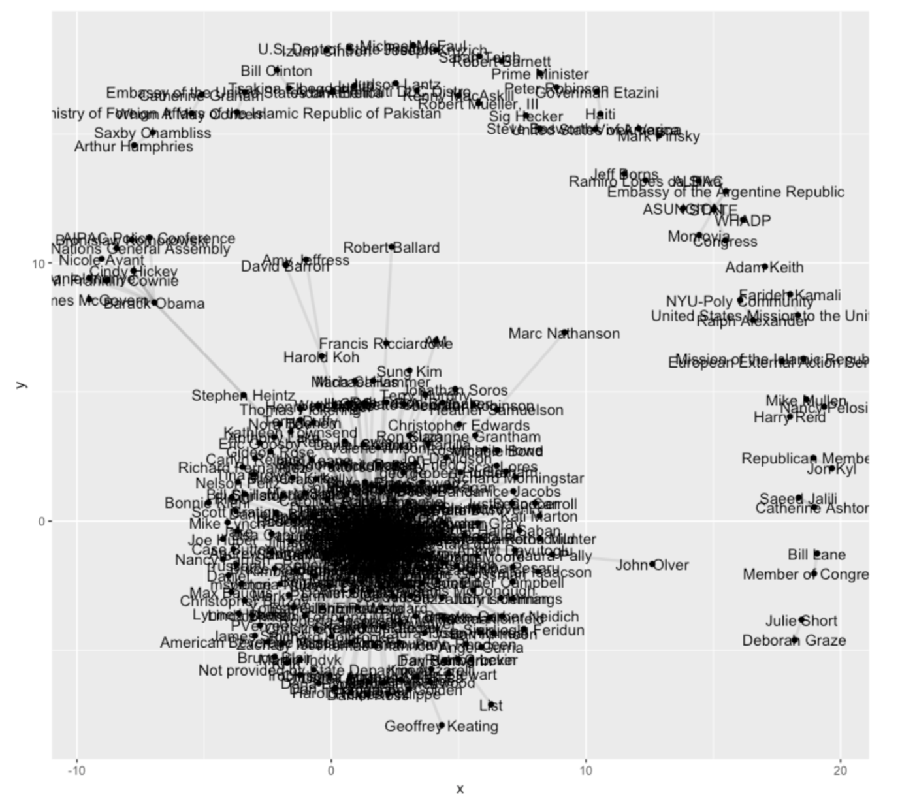clinton_emails %>%

as_tbl_graph(directed = FALSE) %>%

ggraph() +

geom_node_point() +

geom_edge_link(width = 1, alpha = 0.1) +

geom_node_text(aes(label = name))

# Centrality Degree

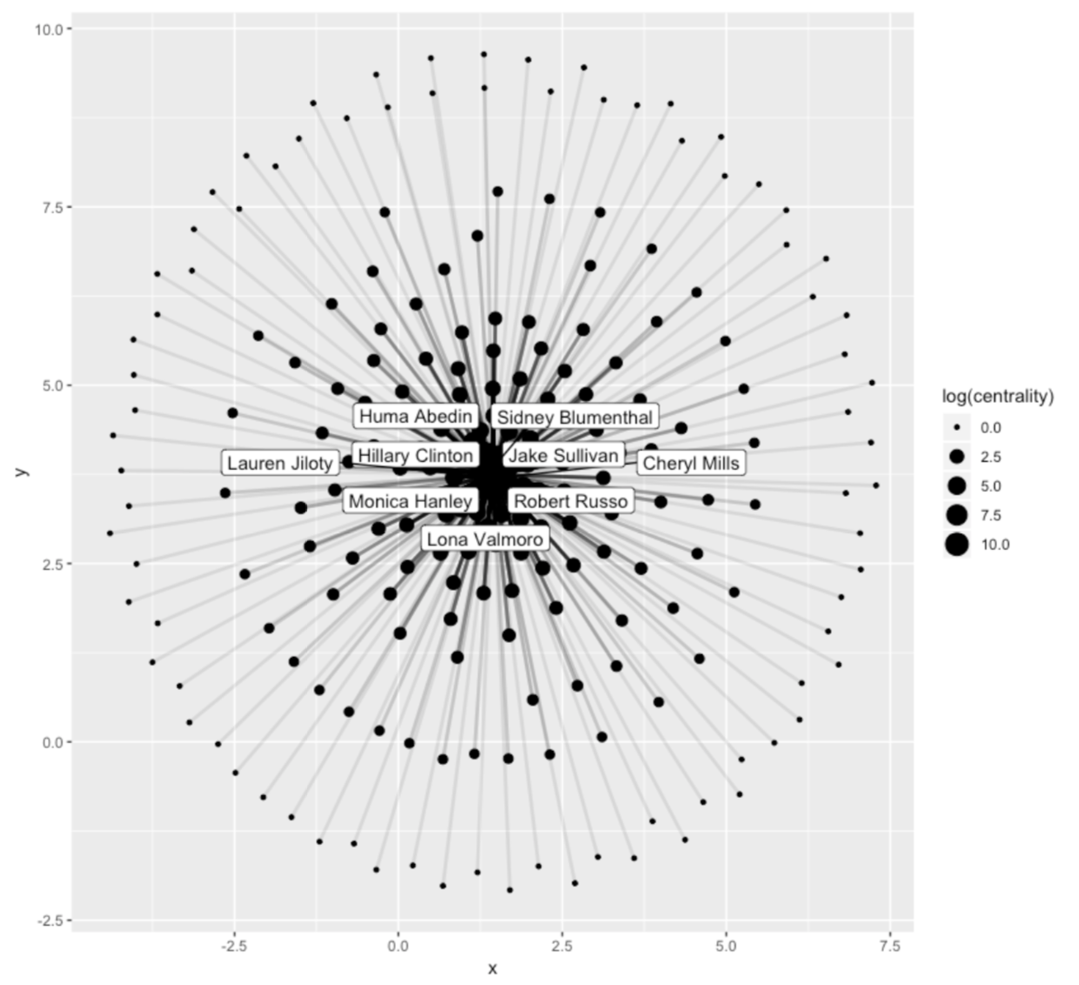

onlyClintonMails %>%

as_tbl_graph(directed = FALSE) %>%

mutate(centrality = centrality_degree()) %>%

ggraph() +

geom_node_point(aes(size = log(centrality))) +

geom_edge_link(width = 1, alpha = 0.1) +

geom_node_label(aes(filter=centrality>=500, label=name), repel = TRUE)

# Edge-Width

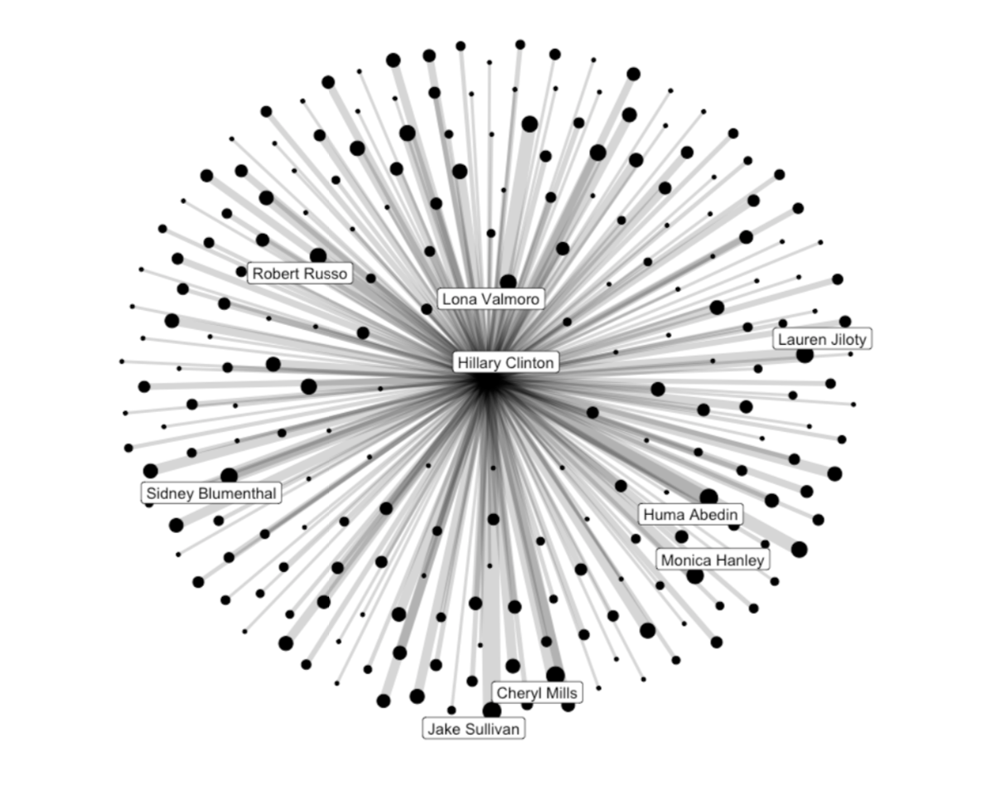

## Count Interactions

|  |  |  |
| --- | --- | --- |
| Hillary Clinton | Contact | count |
| … | … | … |

clinton_emails %>%

group_by(to, from) %>%

summarise(count = n()) %>%

mutate(contact = if_else(to == "Hillary Clinton", from, to)) %>%

arrange(desc(count)) -> contacts

## Merge Data

|  |  |  |  |
| --- | --- | --- | --- |
| From | To | Contact | count |
| … | … | … | … |

clinton_emails %>%

mutate(contact = if_else(to == "Hillary Clinton", from, to)) %>%

left_join(contacts) -> combinedData

## Plot

combinedData %>%

as_tbl_graph(directed = FALSE) %>%

mutate(centrality = centrality_degree()) %>%

activate(edges) %>%

filter(!edge_is_multiple()) %>%

ggraph() +

geom_node_point(aes(size = log(centrality))) +

geom_edge_link(aes(width = log(count)), alpha = 0.1) +

geom_node_label(aes(filter=centrality>=500, label=name),

repel = TRUE)